How to Participate in a Zoom Video Conferencing Meeting:
A Guide for Students & Families

The following is a how-to guide of how to participate in a Zoom meeting for students and families. A video resource is available by going to bit.ly/Participate-Zoom. Should you have further questions please reach out to tech.support@sd23.bc.ca or contact (250)469-6450.

- Participate in a Zoom Meeting via PC or Mac
- Participate in a Zoom Meeting via Mobile Device or Tablet
- Participate in a ZOOM Meeting via Chromebook

Participate in a Zoom Meeting via PC or Mac
- You will likely be invited to join a Zoom meeting via an email invitation or by clicking on a link inside a platform like FreshGrade or Google Classroom. Start by clicking that link.
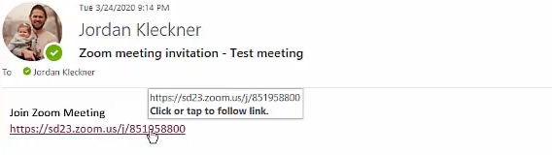
- A tab will now be opened in your internet browser and the meeting will begin to be launched. You will initially be prompted to put in your login name. Once you’ve entered your name click ‘Join Meeting’.
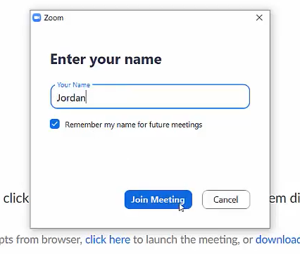

- Join the meeting with your audio by clicking on the blue ‘Join with Computer Audio’ button.
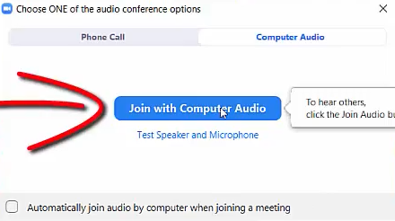

- Make the assumption that your audio and webcam are on! Consider starting by muting your audio and determining if you need your webcam on or off.
- Often users have issues hearing others or being heard/seen by others. This is often due to the fact that you may not have the correct microphone or webcam selected. By clicking on the arrow next to the microphone and webcam you can toggle to the appropriate selection.
.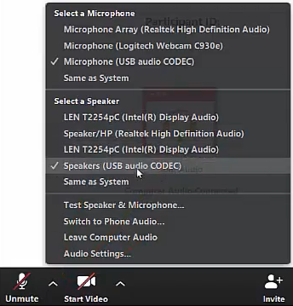
- A great way of engaging as a participant in Zoom is by utilizing the chat functionality by clicking on chat. You have the ability to respond to ‘everyone’ or a certain individual inside the meeting.
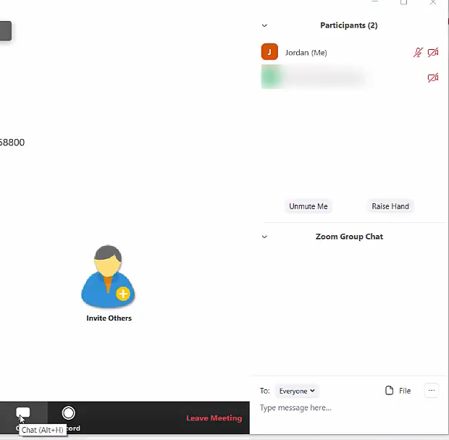

Participate in a Zoom Meeting via Mobile Device or Tablet
- Your initial step is to download the App for the Google Play Store (Android) or the Apple Store (iOS) on your device.
- Once you’ve downloaded the App click on the Zoom icon to launch the App.
- You do not need to ‘Sign Up’ or ‘Sign In’, we suggest simply clicking on the blue ‘Join a Meeting’ button.
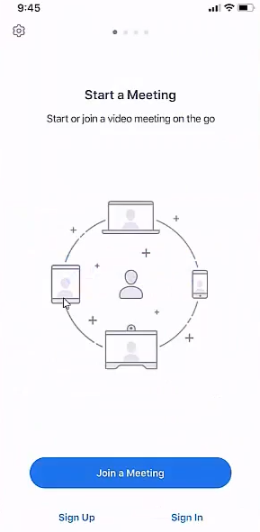
- Next you’ll need to identify the meeting ID. The meeting ID will be the number that was included in the email invitation you received or that was posted inside a platform like FreshGrade or Google Classroom. Enter that meeting ID in as you see below and then enter in your name before clicking on the blue ‘Join” button. You may also want to make changes to your video and audio before entering the meeting (note: if you leave both off it just means you’ll start the meet with your microphone muted and webcam off - you can always change these during the meeting).
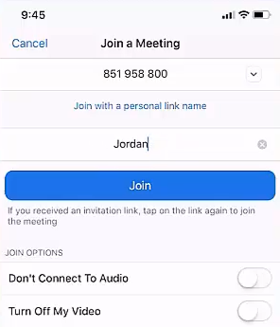

- A screen will open that asks how you would like to hear others. We suggest selecting ‘Call using Internet Audio’.
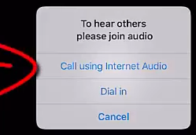

- Make the assumption that your audio and webcam are on! Consider starting by muting your audio and determining if you need your webcam on or off.
- A great way of engaging as a participant in Zoom is by utilizing the chat functionality by clicking on ‘More’. You have the ability to respond to ‘everyone’ or a certain individual inside the meeting.

Participate in a Zoom Meeting via Chromebook
- Your initial step is to install the Zoom App from the Chrome Webstore on your device.
- Once you’ve installed the App click on the Zoom icon to launch the App.
- You do not need to ‘Sign Up’ or ‘Sign In’, we suggest simply clicking on the blue ‘Join a Meeting’ button.
- Next you’ll need to identify the meeting ID. The meeting ID will be the number that was included in the email invitation you received or that was posted inside a platform like FreshGrade or Google Classroom. Enter that meeting ID in as you see below and then enter in your name before clicking on the blue ‘Join” button. You may also want to make changes to your video and audio before entering the meeting (note: if you leave both off it just means you’ll start the meet with your microphone muted and webcam off - you can always change these during the meeting).

- A screen will open that asks how you would like to hear others. We suggest selecting ‘Call using Internet Audio’.

- Make the assumption that your audio and webcam are on! Consider starting by muting your audio and determining if you need your webcam on or off.
- A great way of engaging as a participant in Zoom is by utilizing the chat functionality by clicking on ‘More’. You have the ability to respond to ‘everyone’ or a certain individual inside the meeting.

